[CprE 381] Computer Organization and Assembly-Level Programming, Fall 2017

Lab 4 Report

Name _Larisa Andrews________________________________

Section /Lab Time _2-4 PM Thursday________________________

Refer to the highlighted language in the lab 4 instruction for the context of the following questions.

- [Part II.1] Open the program lab4a.s in SPIM, and run. (5 pts)
- Screenshot of the main window for [Int Regs] and [Text] tabs.
  - 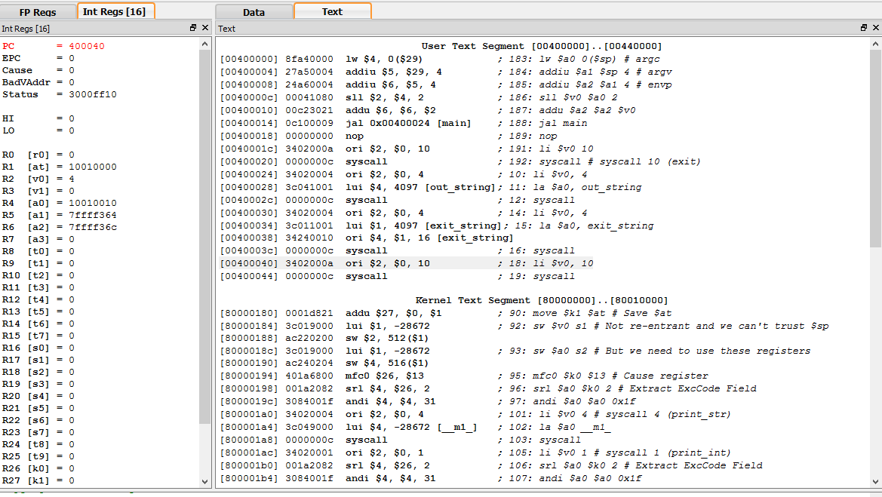
- Screenshot of the console.
  - 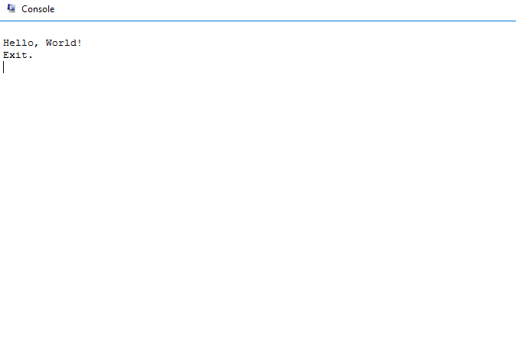
- What is the final value in $v0? Explain why.
  - The value is 4. Because the last call was to print “Exit” to the screen.
- Attach or submit the commented assembly file.
- [Part II.2] (5 pts)
- Screenshot of the main window for [Int Regs] and [Text] tabs.
  - 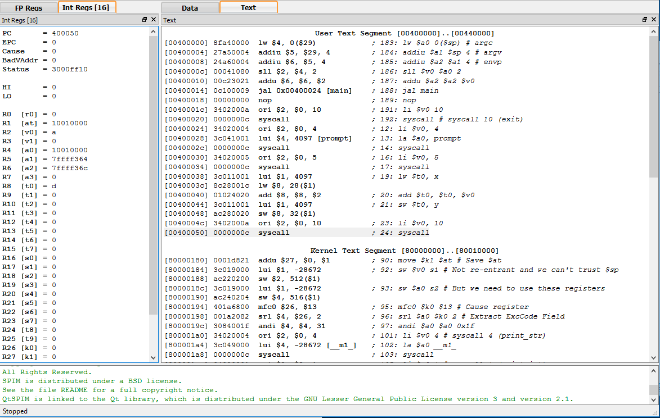
- Screenshot of the main window for [Data] tab; locate the data that has been written by the program.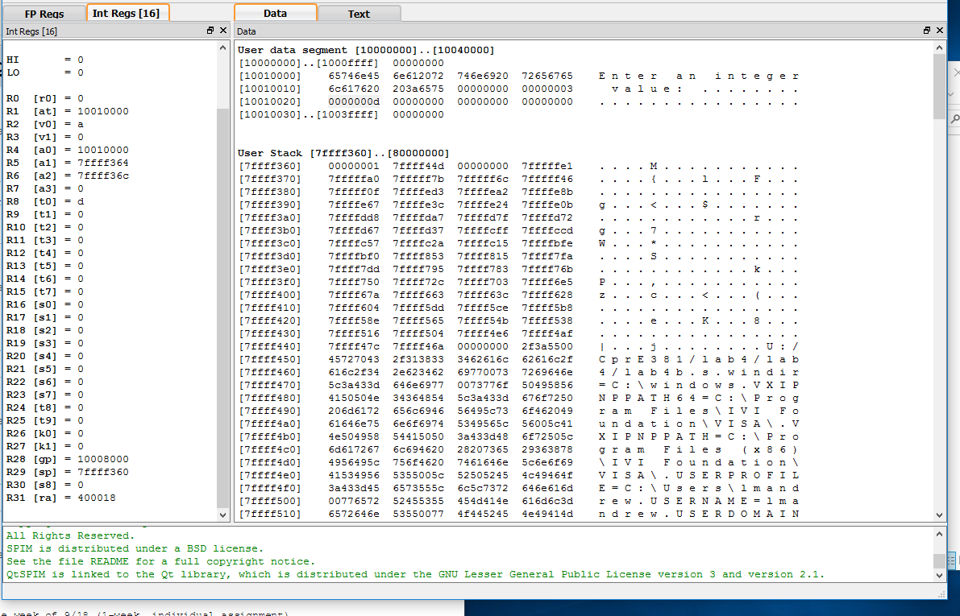
- Attach the commented assembly file on this report or as a separate file.
- [Part II.3] (5 pts)
- Screenshot of the main window.
  - 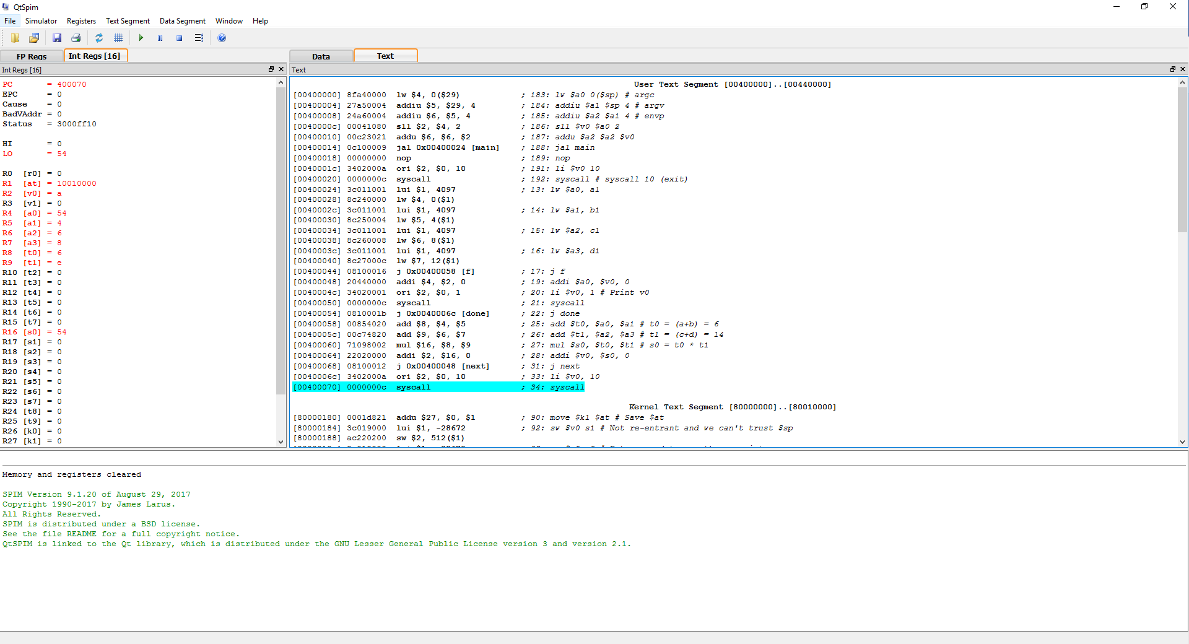
- Screenshot of the console.
  - 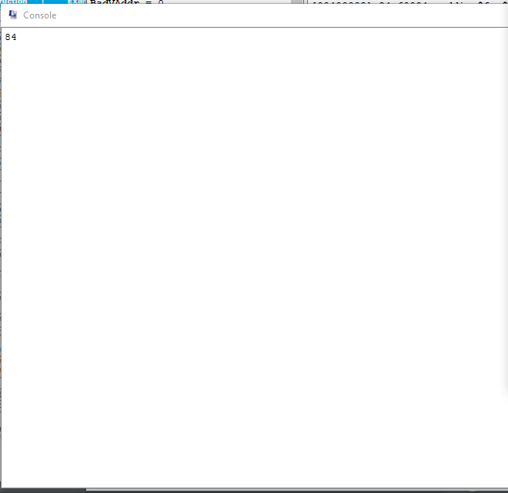
- Investigate the User Stack, and report the value at the opt of the stack before the procedure call is made, during the call, and after the procedure has completed.
  - Before: [7ffff358] 00000001 7ffff44c
  - During: [7ffff358] 00000001 7ffff44c
  - After: [7ffff358] 00000001 7ffff44c
- [Part III.1] (5 pts)
- Locate the procedure in the code, and verity them with the encodings from the book.
- Screenshot of the procedure.
  - 